**Practical:- 2**

**#EBS, CREATING VOLUME**

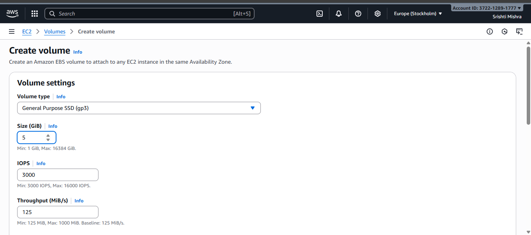

Search EC2 and scroll to volumes.

Click on create volume and choose the settings as per the requirements. (here we have chosen gp3 -> size=5 and rest are default.

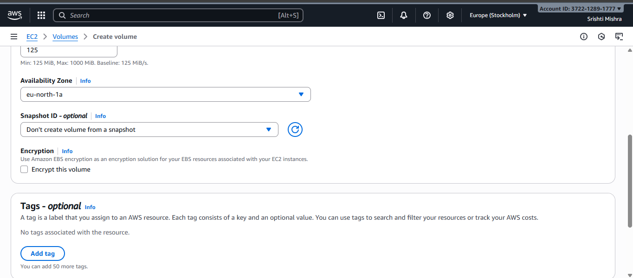

Keep the availability zone as the required zone in other activities too.

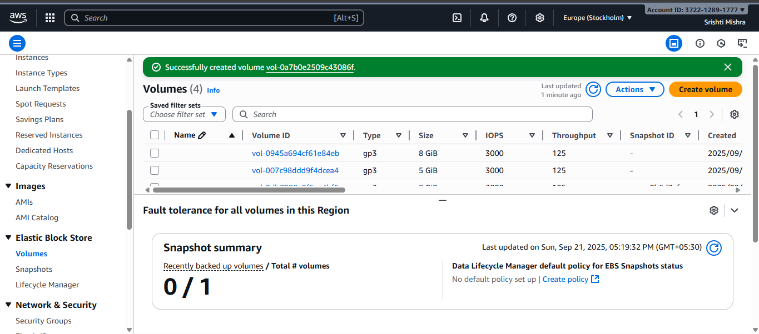

Newly created volume is marked by the red colour.